# Quizz 2

## Grading:

|  |  |  |
| --- | --- | --- |
| 1 | /1 |  |
| 2 | /1.5 |  |
| 3 | /1.5 |  |
| Code quality | /1 |  |
| Total | /5 |  |

Questions

1. For all the following questions, make sure you only create event handlers after the document is loaded (you can add CSS classes if needed).

Create the following event handlers:

1. When the user pushes the hamburger button, the navigation menu (introduction/data) is hidden. When he pushes the button again, the menu is displayed, see figure 1.

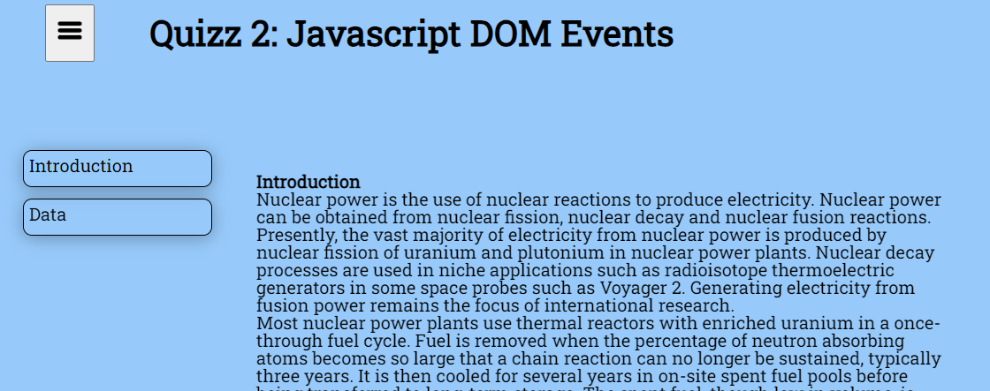

Fig 1: The user hides and shows the menu by pressing the hamburger button.

1. When the user clicks on “introduction”:
   1. the introduction section is displayed
   2. the data section is hidden
   3. the “introduction” menu item takes a font weight of 700 (the data menu item takes the original font weight). Think about the initial state of the “introduction item” when the page opens.
2. When he clicks on the “data” menu item:
   1. the data section is displayed
   2. the introduction section is hidden
   3. the “data” menu item takes a font weight of 700 (the “introduction” menu item takes the original font weight).

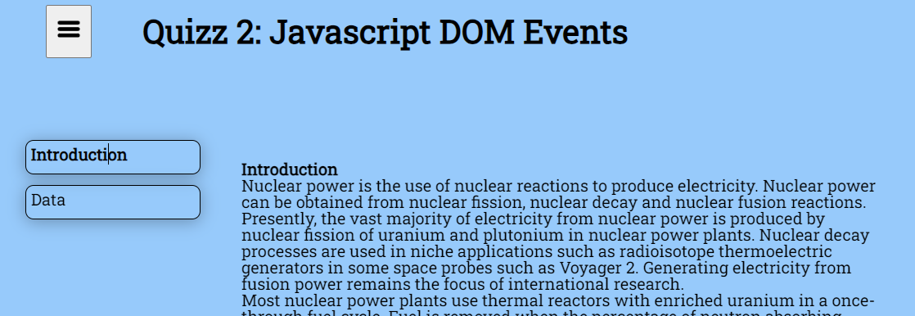

Fig 2: Showing the introduction section then the data section.

END